ABHAYA SAI ENGLISH SCHOOL – MADAPATNA
SA-1 EXAMINATION – 2026-27
SUB – MATHEMATICS
STD – II
NAME: | MARKS: 40

I. Answer the following questions. (5 Marks)
1. What is the opposite of near?
Ans:
- What comes after lighting a candle?
Ans:
- Name one object that is cube-shaped?
Ans:
- Name one object that is cylinder-shaped?
Ans:
- Name any one object that can roll?
Ans:

II. Fill in the blanks. (4 Marks)
1. The bird is sitting ______ the tree.
2. The dog is ________ the table.
3. A ball is ________ the shape.
4. A tin can is ________ in shape.
III. Match the following. (4 Marks)
1) ball cylinder
2) ice cream cube
3) match box sphere
4) tin can cone

IV. Choose the correct answer. (4 Marks)
1. The opposite of top is ________ (near, bottom, above)
2. A pencil box can ________ (slide, fly, swim)
3. An ice-cream cone is shaped like a ________ (cone, cube, sphere)
4. A ball can ________ (roll, slide only, stand)

V. Observe the addition property and complete the remaining. (5 Marks)
1. 6 + 1 =
2. 2 + 6 =
3. 4 + 2 =
4. 8 + 4 =
5. 5 + 5 =

VI. Subtract and match as shown. (5 Marks)
7 - 2 8 8 - 7
9 - 1 2 9 - 4
8 -5 1 8 - 0
3-1 5 7 - 4
6 -5 3 6 - 4

VII. Join the dots in order and color the picture. (1 Mark
Join the dots in number order (1–9) to make the picture, then color it.
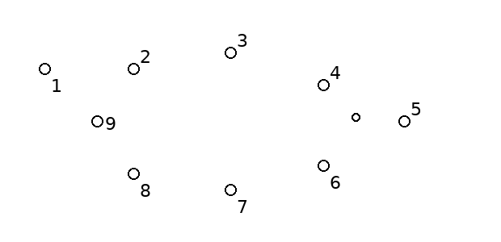

VIII. Units and Tens – Numbers 11–20 (5 Marks)
1. 13 has ______ ten and ______ ones.
2. 16 has ______ ten and ______ ones.
3. Write the number after 17: ________.
4. Write the number before 20: ________.
5. Arrange in ascending order: 15, 12, 18 → ______, ______, ______.

IX. Write the given table. (4 Marks)
7 × 1 = 7 8 × 1 = 8

X. Odd one out. (3 Marks)
Circle the odd one out.
